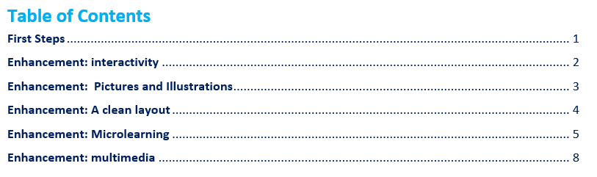

|  |  |
| --- | --- |
| **Online TEE**  Digitally Enhanced Learning | **This resource gives you tips and inspiration to help you create digital resources for your TEE curriculum.**  Based on the sessions by Rick Weymouth, ND Lama, Sharjeel Munawar and Hanna-Ruth van Wingerden |

# **Part one: First Steps**

It will take about two weeks to transfer a TEE course book into a basic app that students can use. An example of this is Canvas. Just transferring the course book in a digital app will give you the absolute basics.

This first part gives you an overview of basic decisions to make and questions to answer. The following pages help you make additions that will help students learn better online.

*Millions of people in Asia use smartphones. That is why your digital course should be mobile-friendly.*

**Important Decisions:**

* Decide which course you will make digital.
* Decide which app you will use. We believe the app needs to be mobile friendly. We believe it will help you greatly if you experiment with using some apps yourself first. You will notice how different apps give you different possibilities and limitations.
* Decide who will carry out the task of putting the material in the app.
* Decide if you will go for just the basics (all the information in an app) or if you will enhance it (see part two of this document for ideas). If you enhance it, decide which IT people and educators will work together, and how they will do this.
* Decide who is responsible for testing, maintenance and problem solving when the app is in use.
* Consider what a digital course means for group leaders. Perhaps you need to involve this into the group leader training.
* Calculate the costs. Think about both manpower and technical costs. Decide who is responsible for fundraising if you need it.

**Questions to research:**

* What is the audience for the chosen course? What do you know already about their learning needs? What do we know about their digital abilities and access to online information? Can we do a survey among students and/or group leaders that will tell us more?
* Is the app we want user friendly? Is it accessible to our students? On what device will the majority access it? If it is not user friendly, what can we do to help our students access it?
* How do we maintain church-based training if we offer a digital course?
* What is the added value for our students? What can we do to add value?
* Does the app allow us to change and edit the content so we can add features later? (If we start with the basics now, could we later enhance it with video, audio, pictures, interactivity, etc.?
* Does the app we want to use have enough features that make it possible to run a TEE course without altering the TEE methodology completely? Note that it is very wise to be flexible, but remember that pedagogy comes before technology!
* How much money can we invest? How are we going to raise funds? How can we share with investors what the benefits of this digital course are?
* 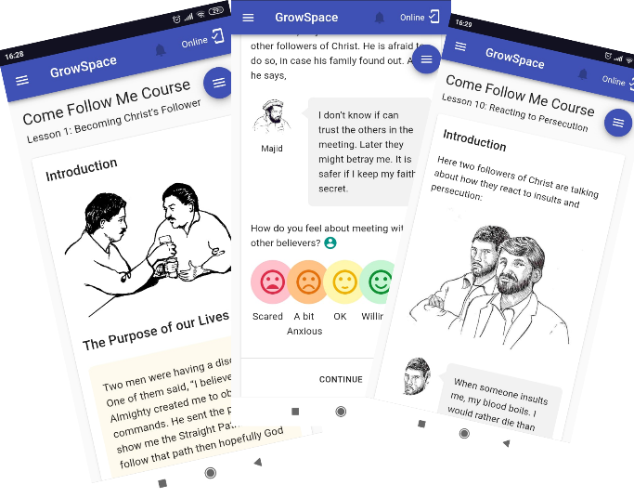Who will train group leaders if they need it to support students? (think about training to use the app, to help people sign in, to look at results, but also training in motiving students if needed, being present online, etc.).
* Do we need more people on our staff team? Or can we hire them on a project basis? If so who is responsible for the decision making?
* Are their others with whom we can work together? Horizon Education Network; SEAN; Word of Life (Growspace); other Increase member programs.

Examples of activities in Growspace

Examples of programs you can use: [Canvas](https://www.instructure.com/canvas), [Moodle](https://moodle.org/), [Gnowbe](https://www.gnowbe.com/), [Growspace](https://word.org.uk/growspace/), and many more.

If you decide to offer mobile courses, you can experiment with [several free apps](https://www.g2.com/categories/microlearning-platforms/free) for microlearning.

*When you develop courses for smartphones, you can enhance an existing course to make it much more interactive and engaging. The next pages give you tips and ideas!*

# **Part two**

# **Enhance the learning experience**

# 

# **Enhancement: interactivity**

Interactivity is an important aspects of any mobile and e-learning event. It helps learners stay focused and engaged. TEE courses already use interactive ways of learning, so the idea is not new. Interactivity in a digital course does look different in some ways.

There are a variety of questions in TEE, and also in other church-based training methods that work well on paper. Answer these questions:

* What kind of different questions are used in TEE courses? What app can we find that is affordable and could incorporate these questions?
* What will we do if we can’t incorporate all these type of questions? Will we sacrifice interactivity (for example open questions) for accessibility? Or will we find another way?

However when we make a digital course, it is very possible to **ADD** features.

* How can we use the way people use their phones to think of additional interactive features that are not present in paper courses?

**Possible enhancements:**

* An app can make it easier to help learners with different learning styles. [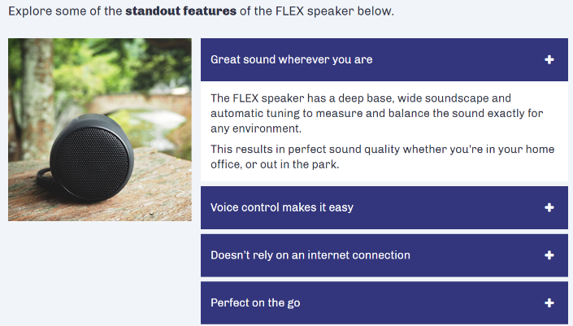](https://www.elucidat.com/showcase/#microlearning-product-knowledge)If we include audio files or videos we speak to auditory learners (people who learn best if they hear something. If we include video and infographics we can help visual learners. An app is helpful for kinesthetic learners: those who learn with movement. Many people learn if they can read things and write about it. They also need to be included.
* In a digital environment we can give learners more autonomy over their learning. You can break information down into different parts. The student can choose the order themselves. This helps learners take responsibility. You should make sure the student can only continue if they read all of the parts.
* We can do the same in click and reveal exercises – [check a good example here](http://storylinesamples.s3-us-west-2.amazonaws.com/AccordionZooApp_RW/story_html5.html) and [another example here](https://360.articulate.com/review/content/b59a7135-702a-40ac-9162-aeba91aff1e2/review). This helps learners make their own decisions while they learn. This helps them to remember it.

Example: Students can click on the part they want to learn more about. It gives them more control. Click on the picture to go to the example online.

* Digital flashcards can be used as a review exercise: [an example](https://360.articulate.com/review/content/2d43a892-4955-43f6-a4e2-bb15b237aeb2/review). This could be done for memory verses, or for key concepts.
* At the end of a session you could give students a checklist to see if they grasped key concepts. This gives them a chance to think about what they have learnt one more time.
* You can ask learners to write or record a short reflection. This could be a WhatsApp message or voice recording to the group leader or the whole group.

# **Enhancement: Pictures and Illustrations**

Is it time to rethink the way we use pictures in TEE? We believe so. We all know a TEE course when we see one. But how appealing do they look to learners nowadays? When you go digital, you have many wonderful options for enhancing courses with coloured pictures and illustrations.

**A good picture:**

* Is connected to the topic.
* Is clear and has high quality
* Fits your overall esthetic.
* Includes only necessary details. You can crop pictures or edit them.

People learn better from words WITH pictures. Learning is more effective if learners can establish connections between words and graphics in their mind.

Tip! Use both visual elements, such as drawings, charts, graphs, maps, or photos, AND text in the form of video or short texts.

Cute picture! But it is not on topic... and it's super grainy!

**Infographics are essential in modern day learning.**

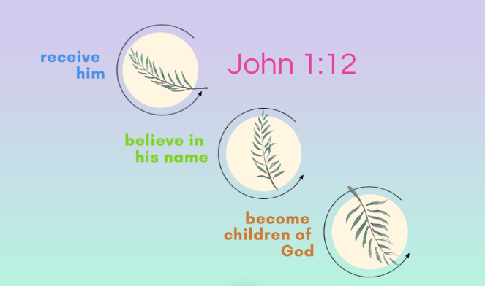You can quite easily make infographics in PowerPoint. You can also use free programs like [Canva](https://www.canva.com/en_gb/) or [Piktochart](https://piktochart.com/).

Think about a colour scheme beforehand so all your infographics are in a similar style.

Tip! If you have an illustrator who makes pictures and infographics it is wise to team them up with an educator.

Simple infographic made in 5 minutes using Piktochart

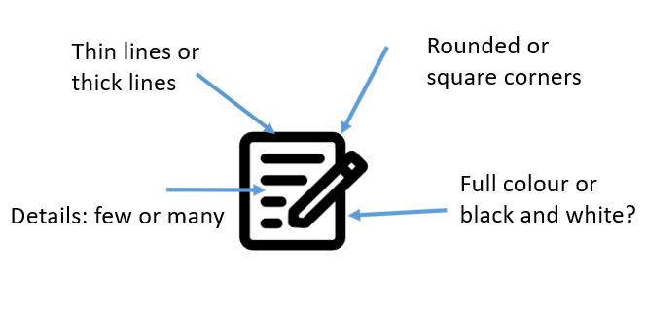**Icons**

Icons are essential to eLearning. It is important to create or find an extensive set that includes all icons you are going to use.

Icons are very helpful to show students what they need to do (read, write, draw, etc.)A free website to find icons is [The Noun Project](http://www.nounproject.org).

Create consistency in your Icon Set

# **Enhancement: A clean layout**

Consistency is key. This is what happens to students if you don’t use images, colours, white-space and text consistently in a digital course:

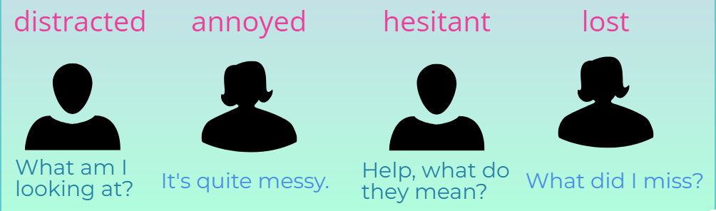

When this happens people will quickly give up. They are not learning. Courses get low homework completion rates and students don’t come back for more courses.

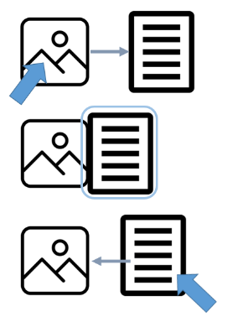**Margins and white space**

Take care of your margins. Good, consistent margins create a sense of calm.

When you’re designing digitally you need to have consistent margins surrounding your text and your pictures. Use more whitespace than you would on paper.

In many programs it’s possible to drag pictures and text in order to create margins and white space.

Remember to be consistent.

**Colour palettes**

Decide to use a colour scheme that is appropriate and not distracting. You can make use of complementary colour schemes that PowerPoint and other programs offer.

You can also create one with websites [Webfx.com](like%20https:/www.webfx.com/web-design/color-picker/:) it shows you what good matching colours are.

Remember that text should be easy to read from the screen.

# **Enhancement: Microlearning**

Microlearning is very simply learning: short sessions of learning. We call this learning chunks, or learning snippets. An example is a YouTube video that teaches you how to check the oil in your car.

Microlearning fits very well with the learning capabilities and skills of the current generation of learners!

**Seven tips for designing good microlearning:**

*This simple infographic is created with SmartArt tools in Word. Note how the icons (free from thenounproject.com) are consistent in style. The seven tips come from: Corbeil, Khan and Corbeil: Microlearning for the digital age (Routledge 2021)*

**Decide the aim of the microlearning snippet**

Each microlearning snippet in your course needs to be:

* Focused on a single objective
* Outcome based
* Stand alone
* Meaningful
* Interactive

It’s good to keep it short, but timing is not the most important issue. The main thing is to teach ONE item per chunk. So each learning element teaches one thing and has one outcome.

Because a microlearning snippet is short, it is vital that learners stay focused. Otherwise they miss the point. To help you design a good learning snippet there are three underlying questions:

* What does the learner need to know or learn?
* Will the learner find this resource useful?
* How will it affect the learners’ learning?

**Choose the form**

Many people think of video as the only form for teaching in microlearning elements. But this is not the only option. Audio and text are also valid options. You can even add pdf’s; but when you use pdf’s consider carefully their readability on smartphones.

We do advise to use just one type of medium per learning chunk. So explain something in a video OR a text, but don’t add both to one learning element.

Use a mix of forms to keep it interesting. Make a video for one element, a scroll-down page for the next, a podcast for another, a pdf or infographic for the third, etc.

When you try to decide what kind of medium would be most suitable for delivering the event, ask yourself:

* What medium or format would be most relevant and specific to the topic?
* What should learners do before, during, and after the event?

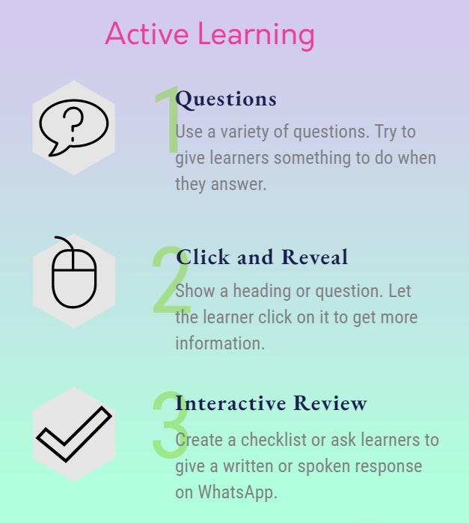**Keep it interesting**

Because the learning chunk is short, we want students to stay engaged from start to finish. Active learning is already a key part to TEE. This can be enhanced in microlearning.

When you develop a microlearning element, think about what will require some input and activity from the learners? Some examples:

* Use different types of questions (multiple choice, fill in the blank, etc.)
* Don’t show all info at once, but ask a question and let the learner click to reveal the answer.
* Make review interactive, for example with a checklist, or a written response to the group via WhatsApp.
* Keep in mind that the options you choose depend on the learning outcome.

**Keep it simple**

Because each snippet is short and focused, it is very important to keep it simple. Asking yourself the following questions can help you stay on track:

* Who is the intended audience?
* What is the best way to present information without dumbing it down?

Each microlearning snippet ideally has one single aim and one outcome. That is why it is good practice, to develop a series of microlearning events. For one TEE lesson you may need 5-10 microlearning snippets.

Remember: the goal is not to cut up the TEE lesson into equal parts. The goal is to connect with, and motivate learners. We want to reshape the lessons so they are meaningful to them and they can take part actively.

**Use tools and apps**

Apps speak to many learning styles. They include about audio, text, visuals and actions. But there are so many apps available! How can you find the right ones? A good place to start is by finding out the answers to the following questions:

* How do I find high quality apps?
* Which apps are good aids for learning in a TEE course?
* Which learning apps do learners already use and like?

The selected app must be able to deliver the key message in a simple, effective way, the app should be easy to set up and easy to use.

# **Enhancement: Multimedia**

We will sum up several tools, apps, and software that are easy to use and that require little technical knowledge. This is not a complete list but a starting point.

**Podcasts**

Podcasts have become very popular over the last couple of years. This tells us it is something learners today engage with easily. A podcast is an effective microlearning tool. It is essentially a micro-lecture on a given topic. Podcasts are an audio tool and easy to make. You can make them on any computer or mobile device using free, or open-source programs. Some examples:

* Audacity for Windows,
* GarageBand on MacOS,
* Voice Memo for iOS, or
* Anchor for Android.

Free websites such as [Soundcloud](http://www.Soundcloud.com) allow you to host podcasts.

**Presentation Software**

Many of you already use presentation software like:

* Microsoft PowerPoint,
* Apple Keynote,
* [Google Slides](https://www.google.com/slides/about/).

Did you know you can use them to create microlearning objects? In PowerPoint you can attach video very simply to your PPT(X) file. You can also use animations, triggers, and feedback to present microlearning events as stories. If you prefer Apple, Keynote is user-friendly and it also comes with themes, animations and effects.

Google Slides does the same. One of the benefits of Google Slides is that people can work together very easily. Students, group leaders and designers can share and edit and co-create learning content.

With all three programs you can also very simply make checklists, quizzes, surveys, and assessments, which can help to reinforce learners’ knowledge.

Tip! If you want your microlearning snippets to look more professional, you could add iSpring to PowerPoint. This software enhances PowerPoint presentations by using content such as videos, branched quizzes, simulations, and interactions.

**Infographics**

You have seen some examples of infographic in this document.

Infographics can break complex data down into simple visuals. Infographics can be useful for reviewing information, or for showing a quick overview of new information.

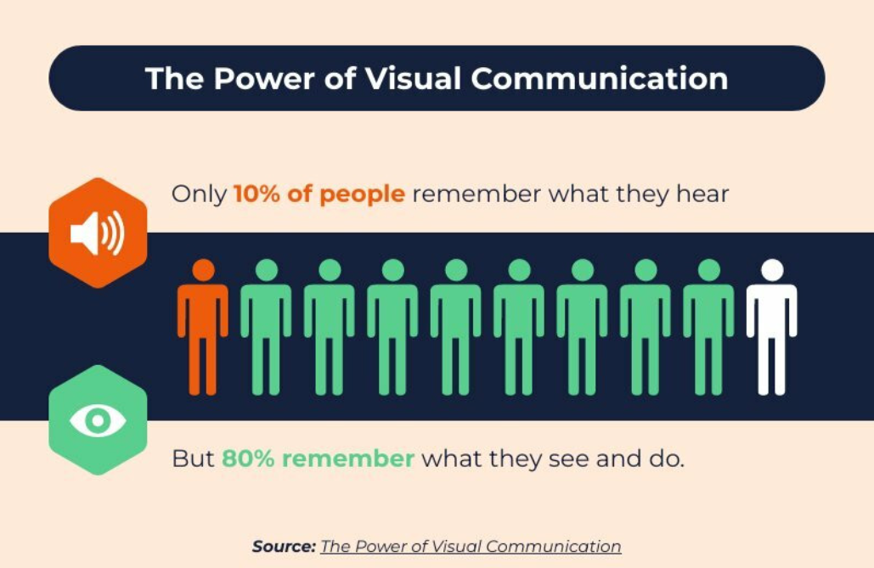Infographics should be easy to understand. So you will have to think carefully about visual elements, such as charts, graphs, and colors.

Text should be minimal and only be used to support the message. Showing both pictures and text is a proven method for deeper learning and understanding.

[Canva](https://www.canva.com/en_gb/) and [Piktochart](https://piktochart.com/) are two easy-to-use web tools for creating dynamic infographics. Infographics can be exported in JPEG or PNG picture format, making them easy to share.

**Videos**

Most learners find videos helpful. It helps many people stay focused.

Videos are useful to give learners high impact, just-in-time forms of learning. The key criteria in good quality videos for learning is that they are that they are engaging and that they give support (explanations, information) to learners when they need it.

You will have to match each video to a specific learning outcome. They are great for explaining deep topics because learners can pause and watch the content more than once to help them understand it.

When you make videos remember: less is more. Keep it focused and use visuals to tell the story. Also think about what learners will do before, during, and after the video.

There are many video creation and editing tools available. IMotion HD for Apple IOS or Magisto Video Editor and Maker for Android are free and easy to use. Microsoft and Apple also offer video editing tools.

**Flashcards**



Interactive flashcards, are easy to create and use. They are an effective and relatively simple option for delivering microlearning for initial learning or review of key concepts and terms. They are easy to create using free online flashcard sites like [Flashcard.online](https://flashcard.online/), and [StudyBlue](https://www.chegg.com/flashcards/create-flashcards).

Some microlearning apps are built completely on the idea of interactive flashcards. See a good example [here](https://www.talentcards.com/tour).

Interactive flashcards can incorporate animations, sounds, and images. For example, a keyword, phrase, number, or image may be on one side of the flashcard, while, on the other side, there is explanatory text or animation. This helps learners to make visual connections with facts or the steps of a process and allow them to quiz themselves on the topic.

**Working together**

Social media makes it possible for facilitators to connect with learners. It is possible to create closed Facebook groups where learners can access and discuss course-related events and share media, including podcasts, videos, PowerPoints, and infographics. Twitter can be useful to summarize or reflect on events in a brief way: because tweets need to be short it can help students filter out the main points.

Social media allow learners to support each other and to feel more involved with their learning group.

Learners can also collaborate in real time to brainstorm ideas by using social sites like

* [Mindmeister](https://www.mindmeister.com/),
* [Cacoo](https://nulab.com/cacoo/)
* [Miro](http://www.miro.com).

Poll and survey tools can increase the participation of learners. Some examples are:

* [Kahoot](http://www.kahoot.com)!,
* [Poll Everywhere](https://www.polleverywhere.com/),
* [Mentimeter](https://www.mentimeter.com/),
* [GoSoapBox](https://www.gosoapbox.com/).

Before or after a microlearning snippet, the group leader could ask questions in one of these apps. This can include open-ended questions, word clouds, or true-or-false statements. Such activities can help to close the feedback loop and provide opportunities for learners to learn from each other.

Working together can deepen levels of learning and understanding as well as help learners feel part of a community.