Life Changing Learning – Session 1

Objectives
In this first session we will:
- Provide an overview of life changing learning principles
- Provide you with sample lessons that show ways that others have used life these principles
- Provide you with opportunities to work on lessons from your own curriculum
After this session, you will be able to:
- Reference some of the life-changing-learning principles that you can use in your training materials
- Point out ways that others have incorporated those principles in their training
- Use those principles in your own training materials

Life Changing Learning Principles

Life change
Transformation is rooted in the life of the students, not in the content of the course. This leads us to the first principle of life-changing learning.

Principle #1
Life changing learning needs to be aimed at people who are currently not doing so well in the area you hope to see change.
What are some implications?
- Training that comes from other places must be carefully reviewed to evaluate its usefulness to the target learners in their application of the learning (not just in the relevance of the content).
- The training is not for everyone. It is for those who need the life change that is developed in the training.
- The training will develop an overall growth process for those who need it. This will include developing competences, relationships, and knowledge over time to ensure successful application for those who need this training.
- The training will include situation specific training so that the application can be as useful as possible.

Principle #2
Life changing learning must be intentionally developed to encourage the life change you want in the learners.
What are some implications?
- Life change never happens after one lesson.
- Life change happens over time.
- Life change happens in relationship with others.
- Life change happens when students are given an opportunity to practice, then to reflect, then to practice again and repeat.
- Life change happens when others around are going through or have gone through similar change.

Principle #3
Life changing learning involves several domains of learning.
What are some implications?
- Educators have generally relied on Bloom’s taxonomy of three domains: the cognitive, affective, and psychomotor. These have often been simplified to know, be, do.
- For Christians, it is important to include one more domain: relationships. (We’ve used know, be, do, relate in our course writing training.)
- The point is that life changing learning must include more than just content.
- Life changing learning recognizes and addresses the various domains and how they contribute to or prevent the life change the training is aimed at.
- Fear not! We are commanded more than any other thing to fear not. Be sure to address fear and other emotions that may hinder life change. (This is part of the affective domain.)
- Assessment will include more than knowledge; it will include other domains, as well.

Principle #4
Life changing learning goes beyond the classroom
What are some implications?
- Life change always involves the people in the learners’ lives. Consider how to incorporate them into the know, be, do, relate aspects of the training.
- Practice and feedback opportunities are available to all learners. Include opportunities for them to practice in situations and with people other than those in the group.
- Provide opportunities for learners to reflect on their experiences.
- Assessment may be difficult because the life change you are aiming at is going to happen outside the classroom/training time. Expand assessment to try to include ways learners can report on their life change. (For example, you can have a pastor, a friend, or others report on the changes they see.)

For reflection
Thinking of your own training materials, tell a partner:
- Which of the principles mentioned stood out to you?
- Which of the principles do you think you would like to work on in these sessions?
- Is there one principle that you think will be especially challenging for you to try to implement into your training?

Life Changing Learning – Sample TEE Lesson

Activity
- Individually, do the lesson on obedience with the 4 principles in mind.
- Then do the group discussion at the end of the lesson.
As you do the lesson, try to answer these questions.
- Is it aimed at people who are currently not doing so well in the area of desired change?
- Is it intentionally developed to encourage life change in the learners?
- Does it involve several domains of learning? (Which ones?)
- Does it go beyond the classroom? (How?)

Abundant Life Sample Lesson 4 – Obedience
The following is section 2 of lesson 4 in the TEE Abundant Life course. Lesson 4 is titled Obedience and follows lessons 1-3 on repentance, faith, and obedience. Lesson 4 focusses on obeying the Lord Jesus Christ in three areas of our life: thought, word, and deed. This section is about obeying with our words.

2 – Christ, the Lord of our Words

But Christ should also
be the Lord of our words.

13. When a believer’s mind and thoughts are changed, his way of talking will be changed as well.
Jesus said:
“Out of the overflow of the heart the mouth speaks.” (Matthew 12:34)
Therefore, if we obey the Lord Jesus in our thought-life, the things which come out of our mouth
will also change. That is, our w__________ will also change.
14. To obey Jesus in what we say we must make sure that we only use good, clean words. Bad language should not come out of a Christian’s mouth. Sometimes a new Christian finds it very hard to break the habit of swearing or lying. But the Bible says:
“Out of the same mouth come praise and cursing. My brothers, this should NOT be.”
(James 3:10)
You are a follower of Jesus Christ so what kind of words ought to come out of your mouth?
a. Only clean words.
b. Bad language.

c. A mixture of clean and foul language.
15. The picture on the right shows an area of our lives in which we
should obey Christ as Lord.
What is it?
The ________ that come out of our mouths.
16. Below are six examples of the use of words. Some of them are good uses, some are wrong. Look
at these examples carefully.
a) Match the kinds of words in the list below with these pictures. Put the letter of the picture in the space provided.
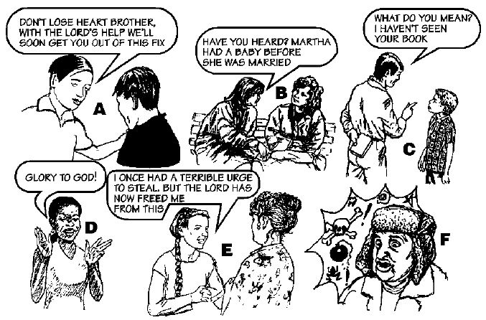

1) Words used to encourage others. Picture ___________
2) Words used to praise God. Picture ___________
3) Words used to gossip and to backbite Picture ___________
4) Words used to talk about Jesus. Picture ___________
5) Words used to lie. Picture ___________
6) Words used to curse. Picture ___________
(16) b) Which are the three pictures in which people are using their words in the right way, and so
obeying Jesus as their Lord?
Write their letters. ______ ______ ______
17. a) If Jesus is our Lord, what should we be doing?
O____________ _________
b) What are the two areas of our life, that we have looked at so far, in which we should be obeying
the Lord Jesus Christ? _______________________ _______________________
----------------- This lesson ends with: ----------------------
Of course, from time to time, you may slip up in thought, word and deed. If this happens make sure you confess it to the Lord and turn away from it immediately.
Then you can be sure that this sin will be f_______________.

24. There are three areas of our life in which we should obey Christ as Lord. What are they?
____thought___, _________________, and _deed____

25. This is the key to a changed life. It is the Abundant Life that the Lord promises us if we obey him in these three ways.
Therefore, we must not only believe in Jesus as our Saviour, but also obey him as our _______.
---------------------------- End of Sample TEE Lesson -------------------------------

Group discussion
When you have finished the lesson, discuss the following questions with your group. Choose someone who can summarize your ideas.
- Which domains of learning are emphasized in this lesson? Which ones are missing? Could any be included to enhance this lesson?
- What opportunities for practice and feedback could you add to this lesson?
- What are two or three things you could have the group leader do to implement some of the principles?
- Discuss one way that you could improve this lesson.

Bonus Principle
Life changing learning will come through the written lessons, through the group leader, and through the relationships of the group members.
What are some implications?
- The training must provide a group leader’s guide that will help the group leader to make sure to emphasize the life changes throughout the training.
- Time must be set aside in the group meetings so the group members can talk about their progress and challenges in the areas of life change they are working on.
- The group should be clear about what life changes they are working on.
- The group should be clear about realistic steps they can take as individual members of the group.
- Plan opportunities for the group members to work on life change together – in pairs, in threes, and as a whole group.
- Assignments outside the group time should include taking practical steps in life change, even if those are simply role playing and practicing with another group member.

Activity
- With the same group, use the bonus principle to develop a home assignment for the lesson “Obeying in Word.”
- Choose one member to share the assignment with the larger group.

Question and Answer – Panel discussion
- Reflect on the principles and activities we just did and write down one or two thoughts that you want to remember. Be prepared to share those with the group.
- Write down one or two questions you would like to ask the facilitators.
Reflect on your own training curriculum and do the following.
- Write down two or three ideas you have about how you might implement these principles into your own training curriculum.

Assignment for Session 2
How would you assess these life changing principles? Talk with someone about this before tomorrow's session.

